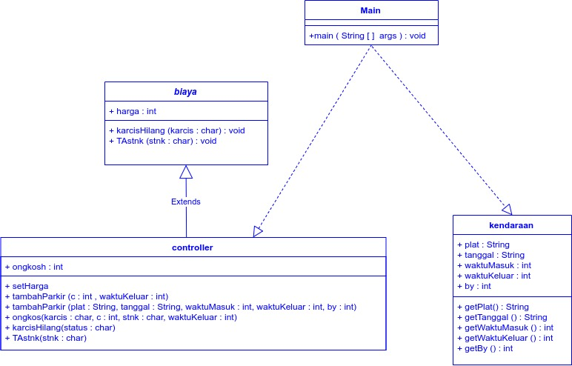

Keterangan Source Code :

------------------------------------------------------------------------------------------------------------------------------------------------------------------------------------------------------------------------------------------------------------------------------------------------------------------------------------------------------------------------------------------------------------------------------------------------------------------------------------------------------------------------------------------------------------------------------------------------------------------------------------------------------------------------------------------------------------------------------------------------------------------------------------------------------------------------------------------------------------------------------------------------------------------------------------------------------------------------------------------------------------------------------------------------------------------------------------------------------------------------------------------------------------------------------------------------------------------------------------------------------------------------------------------------------------------------------------------------------------------------------------------------------------------------------------------------------------------------------------------------------------------------------------------------------------------------------------------------------------------------------------------------